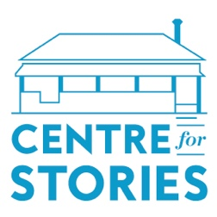

Application for 2021 Centre for Stories Hot Desk Fellowship

Name:

Address:

Contact Number:

Email:

Do you identify as one or more of the following?

- Culturally and/or linguistically diverse

- From a refugee, asylum seeker or migrant background

- Aboriginal and/or Torres Strait Islander

- Living with disability

- LGBTQIA+

If yes, please state which:

Please tell us a bit about yourself. (100 words)

What journals, anthologies, online publications, or platforms have you published in? (Maximum of 5)

How have you participated in the Centre for Stories community – publications, events, workshops, residencies, or other? (100 words)

If selected for participation in the Hot Desk Fellowship what would you work on during your fellowship? (100 words)

How would the opportunity to participate in this Hot Desk Fellowship help you, as both an individual and a writer? (100 words)

I acknowledge the time commitment of 10 days in-person attendance spread out over 8-12 consecutive weeks.

I acknowledge the expected outcomes of the Fellowship:
- To produce at least one completed work (prose up to 3000 words or eight poems) for publication on Centre for Stories website, or in other Centre for Stories publications. We encourage participants to work on more than stated above.
- To participate in events and workshops hosted by the Centre for Stories, when applicable.
I have attached a sample of my writing (in the form of a short story/stories of between 1500-3000 words, 8 poems, or 12 A4 pages of writing/script writing).
Please send completed application form alongside any relevant attachments to: submissions@centreforstories.com

