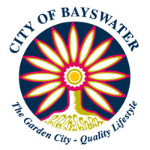
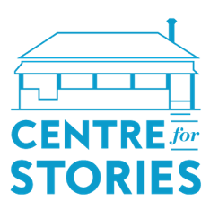

Bayswater Café Residency
Program Guidelines
The following guidelines are flexible and may be adjusted to suit individual needs. We encourage anyone with questions or concerns about aspects of the residency to get in touch.
- Two writers will be selected for participation in the café residency project.
- This program is open to people living in Western Australia. Application is particularly encouraged from writers who identify as culturally and linguistically diverse, Aboriginal or Torres Strait Islander, LGBTQIA+, living with disability, or as being from a refugee, asylum seeker or migrant background. Application is not exclusive to City of Bayswater residents. We accept applications from writers across Perth.
- Application is open to prose and poetry writers only.
- Successful applicants will be required to carry out their residency at Drip Expresso. This is a public venue with high foot traffic, including dine-in and takeaway customers. Ambient noise is to be expected. Applicants must be comfortable working in this environment.
- A key outcome of this program is making writers visible to the general public. Successful applicants will be required to display a “writer-in-residence” sign on their desk, as well as some flyers outlining the program. Applicants must be comfortable with the possibility of interacting with members of the public during the residency (e.g. answering questions relevant to their writing, discussing the residency).
- Successful applicants will receive a dedicated desk at Drip Expresso for a total of 12 days spread out over four to six consecutive weeks between 1 May 2021 and 30 June 2021. The residency can be carried out at a minimum of two days per week over a six-week period, and a maximum of three days per week over a four-week period.
- Successful applicants are expected to be present at their allocated residency venue for a minimum of five hours per day, though specific start and finish times are negotiable depending on individual needs. Applicants will be required to log their hours and submit them to the Centre for Stories at the end of each residency week.
- Successful applicants consent to being profiled on Centre for Stories and City of Bayswater’s website and social media. This includes, but is not limited to, photographs, excerpts of work, and biographical information.
- Successful applicants will participate in a public in-conversation event held at Drip Expresso at the end of the program.
- Successful applicants are required to work on one or multiple pieces of creative writing during the residency and are not permitted to work on tasks or projects unrelated to their creative writing practice while at their residency.
- Successful applicants are required to complete at least once piece of work during their residency for publication on Centre for Stories website, or in other Centre for Stories publications. This constitutes approximately 3000 words for prose or four poems. We welcome submissions from writers who are working on larger pieces of writing, including chapters for publication in anthologies (academic or literary), commissioned pieces of work for magazines, and full-length manuscripts. We encourage writers to get in touch prior to application with specific questions regarding expected residency outcomes.
- Successful applicants will receive a stipend of $400 for their participation. Payment of the stipend will be made in two parts following invoicing from successful applicants. One payment will be made at completion of the first six days, and one upon completion of the 12 days.
- Please fill out the application form and answer the questions carefully. Do not exceed 100 words per answer. Forward the completed application form via email to info@centreforstories.com and include a sample of your work (up to ten A4 pages of writing for prose or eight poems). The sample of writing must be supplied in PDF or Word Doc form and must use the following naming convention: surname_initial_title.pdf or surname_initial_title.doc
- Applications open on 5 April 2021 and close at 10pm on 23 April 2021. Late applications will not be considered for selection.
- Successful applications will be contacted by email during the week of 28 April 2021.

