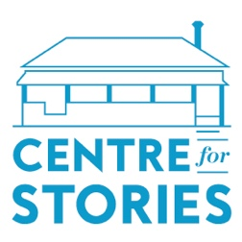
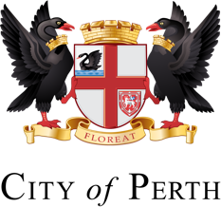

Application for Inner City Residency

Name:

Address:

Contact Number:

Email:

Do you identify as one or more of the following?

- Culturally and/or linguistically diverse

- From a refugee, asylum seeker or migrant background

- Aboriginal and/or Torres Strait Islander

- Living with disability

- LGBTQIA+

If yes, please state which:

Please tell us a bit about yourself. (100 words)

If selected for participation in Inner City Residency, what would you work on during your residency? (100 words)

How would the opportunity to participate in this residency help you, as both an individual and a writer? (100 words)

Please send completed application form alongside any relevant attachments to: info@centreforstories.com

